THE BOOK OF “GEOMETRICAL INEQUALITIES”
AS A COLLECTION OF THE CREATIVE WORK OF
THE STUDENTS

NAIRI M.SEDRAKYAN

The second enlarged edition of the book “Geometrical inequalities” (404 pages) was published in Russian in 2006. It contains more than 1000 problems, a significant part of which include are the result of the creative work of the pupils (these is noted in the book), the other part can be used for stimulating creativity of the students.
For promoting the creativity of the students it is very important, that after considering the special cases they would be able to generalize. Also they should be able to find important applications of the general facts. The problems 13.31-13.33 of the named book can be a good example of acquiring this qualities by students and the report will be devoted to the discussion of these problems.
In 1997 I proposed for the Armenian Olympiad the following problem
Example 1.
For arbitrary points 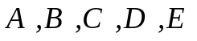 and 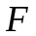 prove the inequality:
.
That inequality can be generalized to the following:
Example 2.
For any hexagon 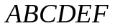 prove the inequality
.
That inequality was the source of a new inequality, which in 2006 was presented on the second Zhautikow Olympiad on mathematics and physics, January 15-20, Almaty, Kazakhstan.
Example 3.
In the convex hexagon it is known that
.
Prove that 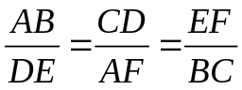.
Now we’ll give two solutions of the last inequality.
We shall prove that for any hexagon the inequality
is true, the equality taking place if and only if
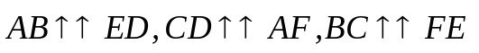 and 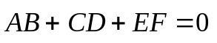.
Indeed, let 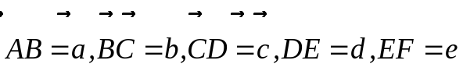. Thus we have that
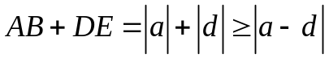,
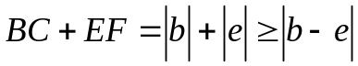,
. (1)
Consequently we find that
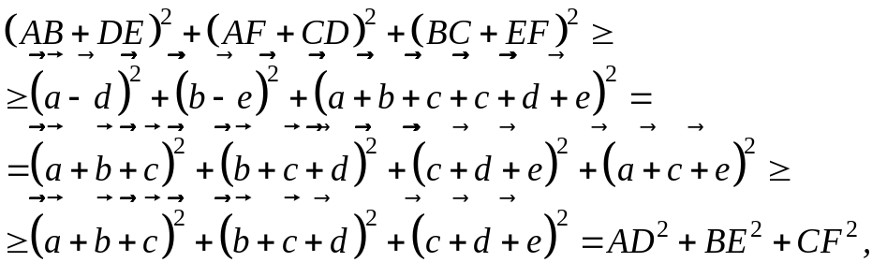
hence
. (2)
Note that the equality in (2) holds if and only if it holds in the inequalities of (1) and 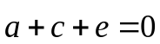, i.e. 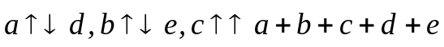 and .
From the conditions of the problem we find that
,
consequently, 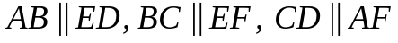 and .
Consider now the parallelogram , then  is also a parallelogram, consequently,  and 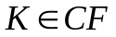, thus 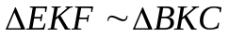, hence 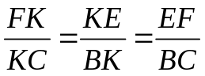, or .
Second solution.
Let 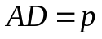, 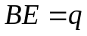, 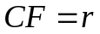 and . Since
,
then 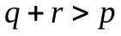. Similarly, we find, that 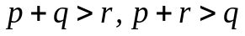, hence one can construct a triangle with sides 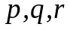.
Note, that 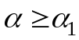 (see Fig.1, Fig.2). Indeed, if 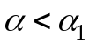, then
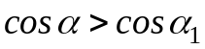 (1)

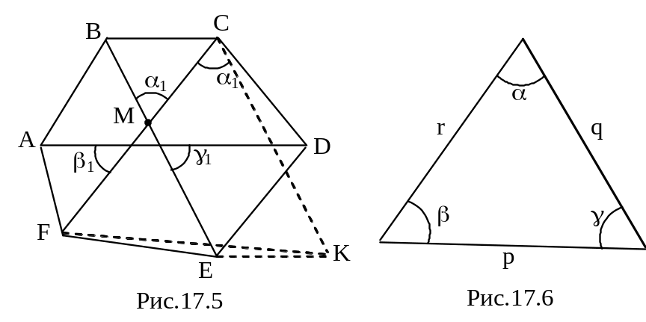
Figure 1 Figure 2

Consider a parallelogram  (Fig.1). We have
,
hence 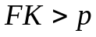. On the other hand
,
which is impossible. Similarly, we find that 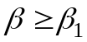, 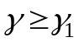, but since 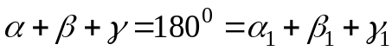, then 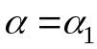, 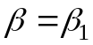, 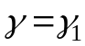. We have found that , consequently 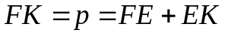, which means that . Since , we have 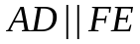 (see Fig.1).
Similarly, we find that 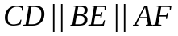, 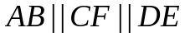, then the quadrangles  and  are parallelograms, and since 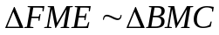, then 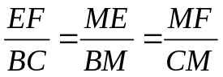 or 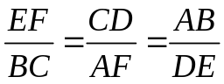.
The Example 3 can be generalized to
Example 4.
For a convex 2n-agon 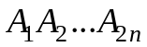 prove the inequality
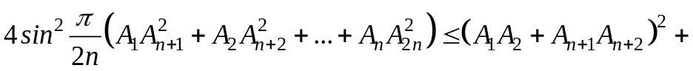
.
The next inequality is closely connected to the inequality of the next example.
Example 5.
For a convex 2n-angler prove the inequality
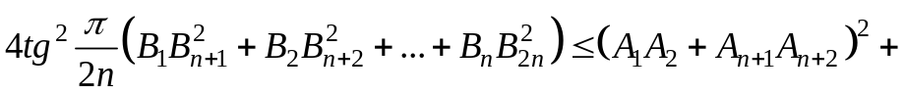
,
where 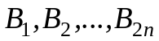 are midpoints of the segments 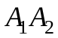, 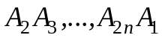, correspondingly.
It is interesting, that for 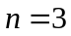 the solution of the Example 5 brings the solution of the problem of the IMO2003.
Example 6.
Given a convex hexagon, for each pair of opposite sides of which the following condition is satisfied: the ration of the distance between the midpoints of these sides to the sum of the lengths of these sides is equal to 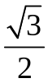. Prove that all angles of the hexagon are equal. (Convex hexagon has three pairs of opposite sides:  and ,  and 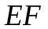,  and 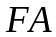).
It turns out, that the solution of the Example 6 is connected with the generalization of the Erdösh-Mordell theorem.

Example 7.
Let  be a point inside the convex -gon 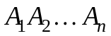.
Denote 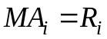, 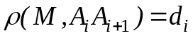, 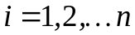, where 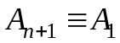.
Prove that 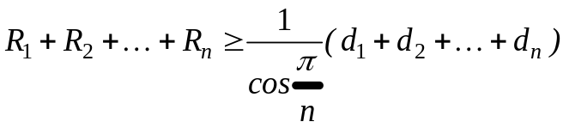.
Now we’ll present solutions of some of the above examples, which I have sent to Titu Andreescu and the “American Monthly” in 2005.
Solution. Lets denote 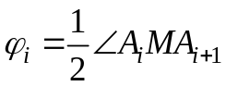, 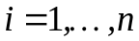.
We have that , where 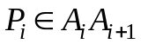 and 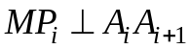, hence
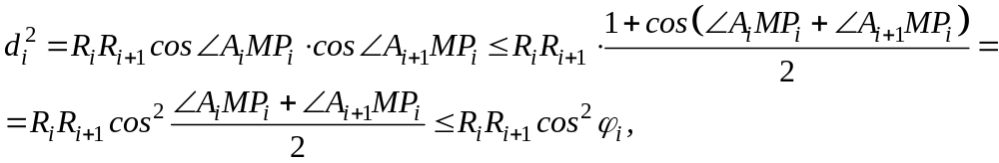
since
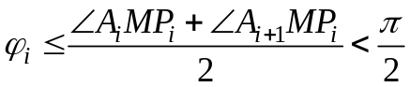.
Consequently,
(1)
It’s clear that 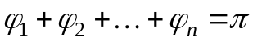, and if we shall prove that
(2)
then from (1) and (2) we find that
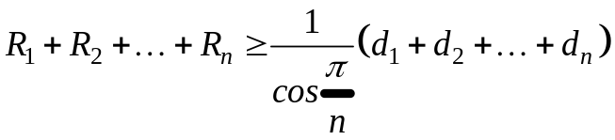.
Consider on the coordinate plane the points 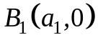, 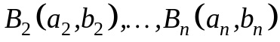, 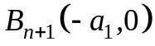 (see Fig.3), such that 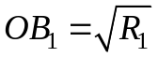, 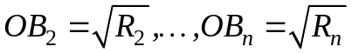, 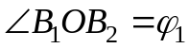, 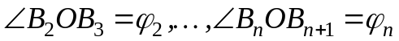.

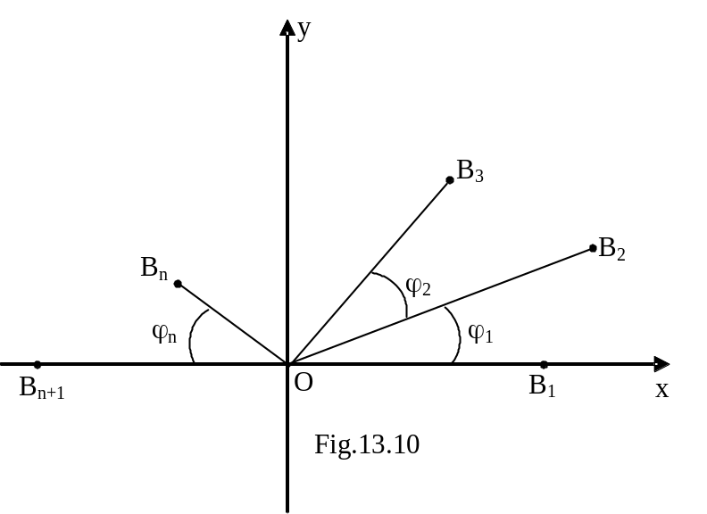
Figure 3

According to the law of cosines 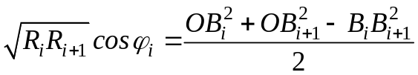, consequently, the inequality (2) takes the form:
and
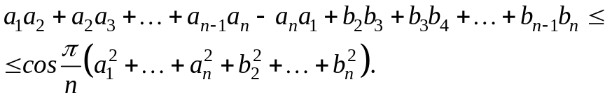 (3)
If we now shall prove that for any numbers
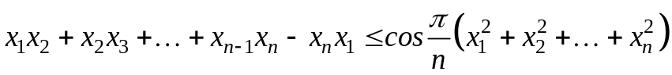 (4)
then we can use the inequality (4) for 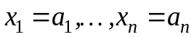 and 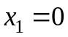, 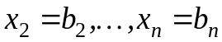, we shall prove the inequality (3).
Thus we have to prove that for 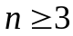 and any numbers 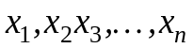 holds the inequality
. (5)
It’s not difficult to check that
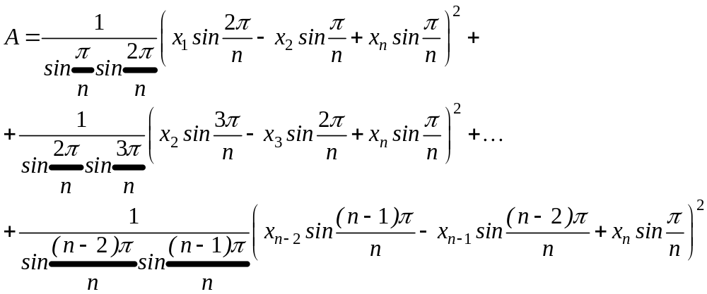 (6)
Consequently the inequality (5) is true.
To prove (6) it remains to note that
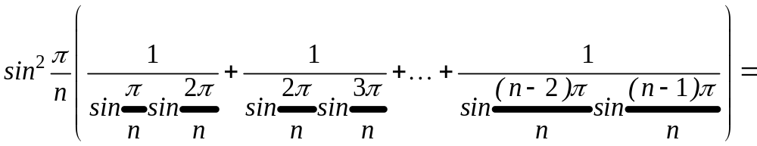
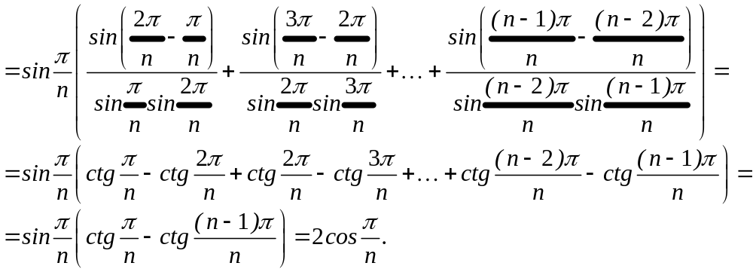
Example 4. Solution. Let 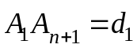, 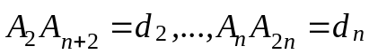, 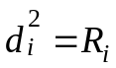, 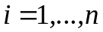, 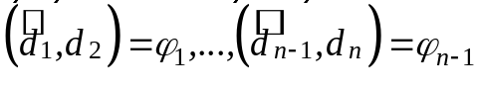 and 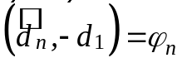.
Note that 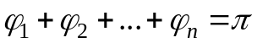
We have that 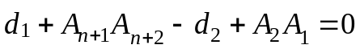, consequently,
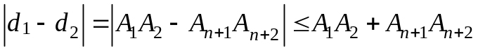,
Hence
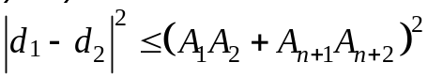
or
.
Similarly. we find that
,…., .
Since 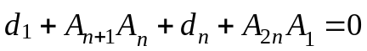, then
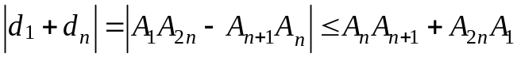,
we have
.
Summing these inequalities we get
(1)
Also we have
(2)
(see the solution of the example 7), hence from (1) and (2) we find that
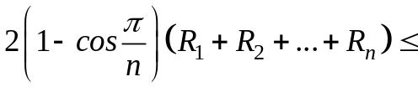
, or
.
Remark. The obtained estimates are exact, since for the regular 2n-gon we have equality.
Example 5. Solution. We have that 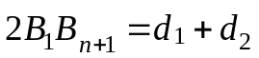, consequently, 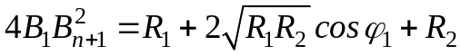.
Similarly we find
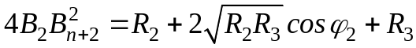,….,
.
We have 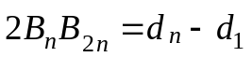, consequently, 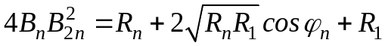.
Summing the obtained inequalities we have
.
According to the solution of the Example 4 we get
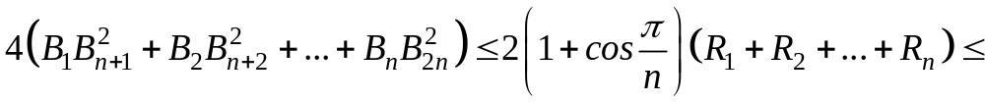
.
Hence
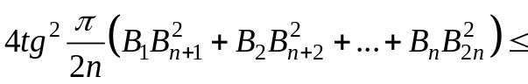.

ABOUT THE AUTHOR
Nairi M.Sedrakyan
Armenia
E-mail: gagri@yerphi.am

